Apache - KAFKA

- Apache Kafka is a open source communication system between sender and receiver.

- Works on publishing and subscribing model.

Reciever

Sender
Kafka

- Ex., Cab booking :-
“Instead of drivers constantly updating a database with their location, which can cause scalability issues due to high throughput, Kafka acts as a messaging system. Drivers publish their real-time location updates to a Kafka topic. Users' applications then subscribe to this topic to receive continuous location updates for their booked cab.
This approach allows for high throughput and efficient handling of many simultaneous updates, as Kafka is a distributed system.”

- What are producers and consumers?
Producers: These are applications or processes that send (publish) data to Kafka topics. They write messages to Kafka.
Consumers: These are applications or processes that read (subscribe to) data from Kafka topics. They consume messages from Kafka.

- Advantages
High Throughput: Handles large volumes of data and transactions efficiently.
Fault Tolerance: Ensures data safety and continuous operation through replication (leaders and followers).
Scalability : Easily expands by adding more servers/clusters to manage increasing data load.
Real-time Data Streaming: Kafka data pipelines seamlessly ingest, process, and deliver streaming data. It acts as a central nervous system for your data and handles data as it flows in real time.

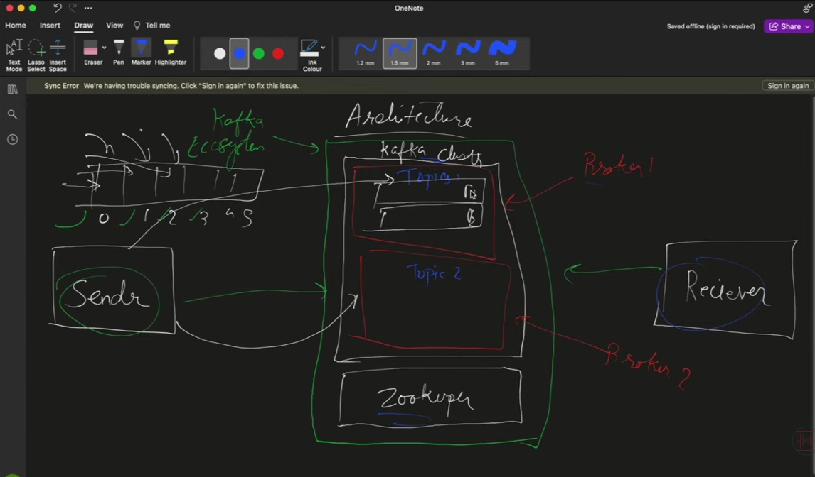
- Architecture ?? I didn’t get. Check later…

- Offsets? Ex.., --from-beginning. (default: real-time)

- Go to the Apache Kafka site and try their example using multiple terminals.
- Download
- Extract using given commands
- Do the directory “bin” of windows folder of extracted kafka.
- Then open terminal their and perform the given commands of server
- Then open second terminal for producer – do same
- Third for consumer

Dictionary:
- Cluster
- Brokers
- Topic
- Partitions
- Offset – from beginning and etc
- Zoo-keeper
- Kafka ecosystem
- Follower
- Leader
- Subscribe and publish
- Sender and receiver
- Replicas
- Apache Kafka
- Architecture and its model

